**Lab 26: Android Notification using Kotlin**

# **Introduction**

Even when the programme is not active, Android Notifications deliver quick, pertinent information about the action that took place. The emblem, title, and a portion of the content text are displayed in the notice. Using the NotificationCompat.Builder object, Android notification properties are set.

Some of the notification properties are mention below:

* **setSmallIcon()**
* **setContentTitle()**
* **setContentText()**
* **setAutoCancel()**
* **setPriority()**

**Let’s get Started:**

In this experiment we will develop an Android App to demonstrate the use of Android Notification Manager.

**Step 1: Create a New Project in Android Studio as shown below**

**Step 2: Select Empty Activity as shown below**

**Step 3: Provide a Project Name as shown below**

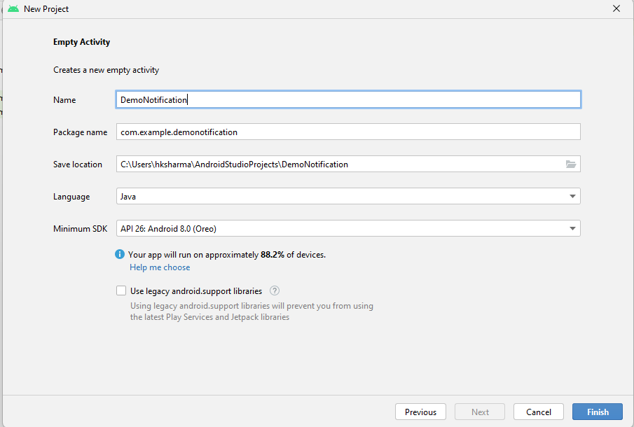

**Step 4: Update MainActivity.kt as per the code given below**

**package** com.example.demonotificationkotlin  
**import** android.app.Notification  
**import** android.app.NotificationChannel  
**import** android.app.NotificationManager  
**import** android.app.PendingIntent  
**import** android.content.Context  
**import** android.content.Intent  
**import** android.graphics.BitmapFactory  
**import** android.graphics.Color  
**import** android.os.Build  
**import** android.os.Bundle  
**import** android.widget.Button  
**import** android.widget.RemoteViews  
**import** androidx.appcompat.app.AppCompatActivity  
  
**class** MainActivity : AppCompatActivity() {  
  
 *// declaring variables* **lateinit var notificationManager**: NotificationManager  
 **lateinit var notificationChannel**: NotificationChannel  
 **lateinit var builder**: Notification.Builder  
 **private val channelId** = **"i.apps.notifications"  
 private val description** = **"Test notification"  
  
 override fun** onCreate(savedInstanceState: Bundle?) {  
 **super**.onCreate(savedInstanceState)  
 setContentView(R.layout.*activity_main*)  
 **val** btn = findViewById<Button>(R.id.*btn*)  
 **notificationManager** = getSystemService(Context.*NOTIFICATION_SERVICE*) **as** NotificationManager  
 btn.setOnClickListener **{  
 val** intent = Intent(**this**, afterNotification::**class**.*java*)  
 **val** pendingIntent = PendingIntent.getActivity(**this**, 0, intent, PendingIntent.*FLAG_UPDATE_CURRENT*)  
 **val** contentView = RemoteViews(*packageName*, R.layout.*activity_after_notification*)  
 **if** (Build.VERSION.*SDK_INT* >= Build.VERSION_CODES.*O*) {  
 **notificationChannel** = NotificationChannel(**channelId**, **description**, NotificationManager.*IMPORTANCE_HIGH*)  
 **notificationChannel**.enableLights(**true**)  
 **notificationChannel**.*lightColor* = Color.*GREEN* **notificationChannel**.enableVibration(**false**)  
 **notificationManager**.createNotificationChannel(**notificationChannel**)  
  
 **builder** = Notification.Builder(**this**, **channelId**)  
 .setContent(contentView)  
 .setSmallIcon(R.drawable.*ic_launcher_background*)  
 .setLargeIcon(BitmapFactory.decodeResource(**this**.*resources*, R.drawable.*ic_launcher_background*))  
 .setContentIntent(pendingIntent)  
 } **else** {  
  
 **builder** = Notification.Builder(**this**)  
 .setContent(contentView)  
 .setSmallIcon(R.drawable.*ic_launcher_background*)  
 .setLargeIcon(BitmapFactory.decodeResource(**this**.*resources*, R.drawable.*ic_launcher_background*))  
 .setContentIntent(pendingIntent)  
 }  
 **notificationManager**.notify(1234, **builder**.build())  
 **}** }  
}

**Step 5: activity_main.xml**

*<?***xml version="1.0" encoding="utf-8"***?>*<**RelativeLayout  
 xmlns:android="http://schemas.android.com/apk/res/android"  
 xmlns:tools="http://schemas.android.com/tools"  
 android:layout_width="match_parent"  
 android:layout_height="match_parent"  
 tools:context=".MainActivity"**>  
  
 <**Button  
 android:id="@+id/btn"  
 android:layout_width="wrap_content"  
 android:layout_height="wrap_content"  
 android:layout_centerInParent="true"  
 android:text="Send Notification"** />  
  
</**RelativeLayout**>

**Step 6: create afterNotification.kt and add code in**

**activity_after_notification.xml**

*<?***xml version="1.0" encoding="utf-8"***?>*<**RelativeLayout  
 xmlns:android="http://schemas.android.com/apk/res/android"  
 xmlns:tools="http://schemas.android.com/tools"  
 android:layout_width="match_parent"  
 android:layout_height="match_parent"  
 tools:context=".afterNotification"**>  
  
 <**TextView  
 android:id="@+id/textView"  
 android:layout_width="wrap_content"  
 android:layout_height="wrap_content"  
 android:layout_centerInParent="true"  
 android:text="Welcome To Snap Notification"  
 android:textSize="15sp"  
 android:textStyle="bold"** />  
  
</**RelativeLayout**>

**Step 7: Output**

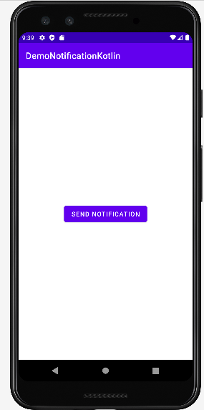

**Voila!!** We have successfully completed this lab.